ComMOCSvc service extension for file processing
GEA Image Extractor
Conception Document

Reference : |  |  |  | Revision : | C | Date : | 24/02/2004
Verified by: |  |  | Date : |  |  | Visa :
Approved by: |  |  | Date : |  |  | Visa :
Author : | T. Cvitanic
Project Name : |  | HAC
Project Redo :
Diffusion list:

HISTORY EVOLUTION

Version | Date | Evolution | Author
A | 29.10.2003 | Creation | TC
B | 4.11.2003 | The module is adapted to use the new WorkerProcessFileEx function | TC
C | 24.02.2004 | The file purge procedure description has been added. The parameter list has been updated. | TC

TABLE OF CONTENTS

1. Introduction 4
1.1. Document presentation 4
1.2. Glossary 4
1.3. Referent documents 5
2. MODULE PrEsentation 6
2.1. Functional diagram 6
2.2. Module parameters 8
2.3. File processing 9
2.3.1. File naming convention and the subdirectory tree 9
2.3.2. File backup 10
2.3.3. File processing error 10
2.3.4. File purging 10

Introduction

Document presentation
The purpose of this document is to describe the ComMOCSvc service extension module that extracts the picture form the GEA image file.
The module contains three exported functions that are described in the "Dossier de conception de CommocSvc.doc" document. The ComMOCSvc service uses these three functions to initiate the module, process detected file and close the module.

Glossary
MOC Central system
GEA Grenobloise d’Electronique et d’Automatismes

Referent documents
Dossier de conception de CommocSvc.doc | Revision: B
Manuel de maintenance de CommocSvc.doc | Revision: B

MODULE PrEsentation
The GEA image file consists of:
- header that contains the information about the transaction and picture
- one or two pictures in the JPG format
The GEA image extractor module detects how many pictures are stored in the GEA image file. It extracts the pictures and stores them into the file in the appropriate directory. The file naming convention and the directory tree structure will be explained in the next document sections.

Functional diagram
The module uses four directories for the file processing. The "LocalMailIn" directory contains the GEA image files that have to be processed. As soon as the ComMOCSvc service detects the new file in the "LocalMailIn" directory it calls the WorkerProcessFileEx function. This function first extracts the GEA image file header that contains the information related to the image (where the image is acquired, when it is acquired, why it is acquired etc.). Also, the header file contains the information of how many pictures are stored in the file (one or two) and size of the first picture. Using this information the module extracts the picture or pictures form the file and store them into the "OutDirectory" directory. If the picture is successfully extracted and stored in the file, the original GEA image file will be moved to the "LocalMailInAck" directory. If the file processing is not successful the GEA image file will be moved to the "LocalMailInErr" directory.
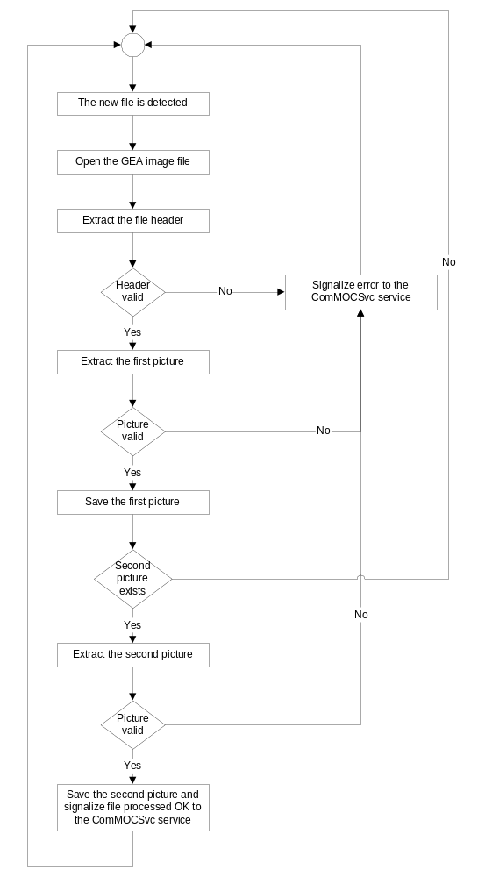

Module parameters
The module parameters are stored under the HKEY_LOCAL_MACHINE\System\CurrentControlSet\Services\CommocSvc\Parameters\Workers\ModuleName registry key where the ModuleName can be any string. It means that the user can start many instances of the module and he can give them different names (and adjust different parameters).

Module registry parameters description
Variable name | Variable type | Description
Dll | String | csr_cmworkgeaimg.dll – the name of the library from which the ComMOCSvc service will call the module functions.
PollingPeriod | Dword | This parameter adjusts the time between two directory checking (in milliseconds).
TraceFile | String | Name of the module trace file.
LocalMailIn | String | This is the directory where the GEA image files are stored. The ComMOCSvc service checks this directory to detect if there is any new file to process.
LocalMailInAck | String | Successfully processed GEA image files are stored in this directory.
LocalMailInErr | String | Unsuccessfully processed GEA image files are stored in this directory.
OutDirectory | String | This is the directory where the successfully extracted pictures are stored.
MaxAckFiles | Dword | Maximal number of files stored in the LocalMailInAck directory.
MaxAckKB | Dword | Maximal cumulative size of files stored in the LocalMailInAck directory.
MaxErrFiles | Dword | Maximal number of files stored in the LocalMailInErr directory.
MaxErrKB | Dword | Maximal cumulative size of files stored in the LocalMailInErr directory.
NameMask | String | The file name mask. The module will not process the files that not belong to defined file name mask.
InAndAckDelete | Dword | If this parameter is set to 1 and if the service detects the same file in the LocalMailIn and LocalMailInAck directory the files will be deleted.
InAndErrDelete | Dword | If this parameter is set to 1 and if the service detects the same file in the LocalMailIn and LocalMailInErr directory the files will be deleted.
NetworkMultiplier | Dword | This parameter is used to concatenate the GEA network number to the GEA plaza ID. In this case the CSSI plaza ID is equal to GEA network ID * NetworkMultiplier + GEA plaza ID,
PurgeTime | String | This is hour and minute at which the purge procedure will be started.
PurgePeriod | Dword | The PurgePeriod parameter determines how many days the picture will be stored on the local disk.
LastPurgeDateTime | String | The module updates this parameter every time when the purge procedure is successfully finished. The module uses this value to detect the date and time of the next picture purging.

File processing

File naming convention and the subdirectory tree
Using the data from the GEA image file header the module creates the file name and subdirectory in which the image will be stored. All the extracted images are stored in the "Out" directory (defined in the module parameters) and subdirectory defined by the lane name from the image header file and the month and day of the image acquisition. The file name has following format:
PPPPLLLYYYYMMDDHHMISEJJTTTTTI.JPG

- PPPP is plaza number
- LLL is lane number
- YYYY is year of the image acquisition (trs. generation)
- MM is month of the image acquisition (trs. generation)
- DD is day of the image acquisition (trs. generation)
- HH is hour of the image acquisition (trs. generation)
- MI is minute of the image acquisition (trs. generation)
- SE is second of the image acquisition (trs. generation)
- JJ is job number
- TTTTT is transaction number
- I is picture index

The subdirectory tree has following structure: Out directory =>Lane name directory=>Month directory=>Day directory.

File backup
After the GEA image file is successfully processed it is moved to "LocalMaiInAck" directory by the ComMOCSvc service. Adjusting the module parameters it is possible to limit the number of files in the "LocalMailInAck" directory and their cumulative size.

File processing error
The GEA image file doesn't have the check sum or message ID and it is difficult to detect the wrong format of the image file. The module can detect if the file is smaller than the message header or if it can't extract the picture. In the case of an error the module signalize the error to the ComMOCSvc service. The service moves the file in the "LocalMailInErr" directory. The same as for the "LocalMailInAck" directory it is possible to adjust the module parameters to limit the number of files and their cumulative size.

File purging
If the PurgePeriod module parameter is different from zero the module will purge pictures. All the pictures acquired before the date calculated by subtracting the number of days defined by the PurgePeriod parameter from the system date would be purged automatically. The purge procedure will be started every day at the time defined by the PurgeTime parameter. If the PurgePeriod parameter is set to zero the purge procedure will not be started.

